Nation States

Nation States – characterised by its territory

“territorial trap” – we are so used to thinking in terms of nation states that it had also moulded other sciences and other fields. I.e. we do not dispute that there are boundaries.

The nation state is the only political regime that has dominated the entire world totally. States have mutual recognition.

Sovereignty – having ultimate decision-making power. An element of unaccountability (he makes the laws, but he is not bound by the law). Replication of god’s dominion over a limited space.

Foucault said that the 20th century sovereign is panopticon. "He who is subjected to a field of visibility, and who knows it, assumes responsibility for the constraints of power; he makes them play spontaneously upon himself; he inscribes in himself the power relation in which he simultaneously plays both roles; he becomes the principle of his own subjection"

“The Optic of the State: Visuality and Power in Argentina and Brazil” – Jens Andermann

The panopticon is proposed by Bentham, where only one guard sits in the middle of a circular arrangement of prisoners’ cells -> more efficient ways of policing. (Who knows if the prisoners are being watched by the god or not). Using visibility as a means of internalising force.

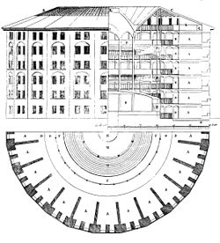 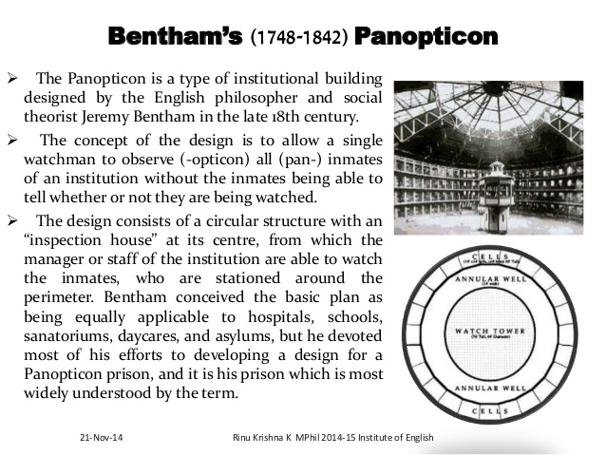

Map slowly became a tool for political rule

The Dardanelles attack by Winston Churchill failed because of faulty maps.

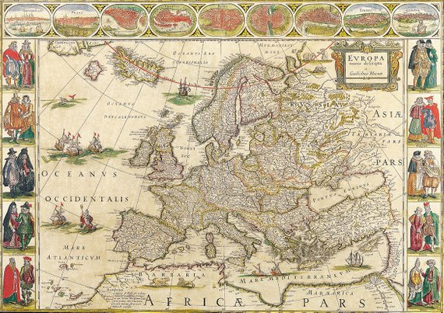

Europe 17th century (Blaeu)

The map anticipates the nation-states. At that point in time in the 17th century, Italy and Germany had not been unified, but we can identify these countries on the above map. Maps also change political practices. Rules and allegiances that couldn’t be shown on the map were slowly eliminated.

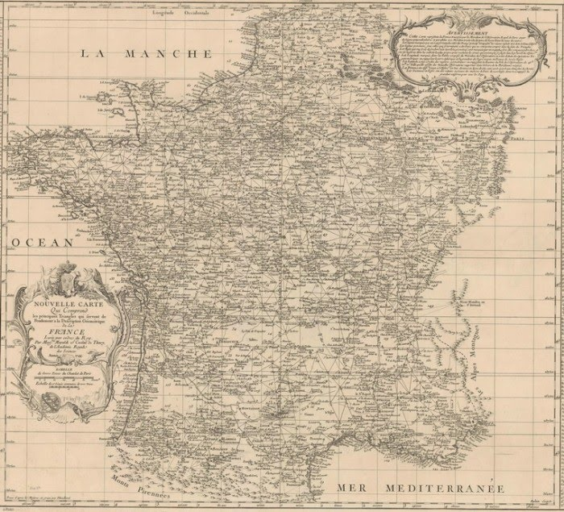

Cassini map of France

Triangulation network was started by Cassini – created the most precise map. “You had taken more territory off my kingdom than any invaders had” – France’s king.

Kings used to be always travelling as they had to always be there physically. Once you have the map, you don’t have to travel (administers the country from the capital).

The nomads and gypsies were then eliminated eventually because of the territory boundaries. Sedentarity was achieved – to stay in one place. This is vital for the nation state, resulting in public delegitimating of nomads and gypsies.

The rejuvenation of anti-semitism (and Holocaust) is partly due to Jews being ‘rootless’. Up until 20th century, you had to be a land owner to have the right to vote. Only the land owners have a true concern to the country (because they are bound to the nation). -> democracy was space based.

If you are not in your soil (exile), you are a little less of yourself. (“The Foreigner”). The theme of nature/natural. Use nature to legitimatise political ambitions.

Belgium lion (Leo Belgicus) – using the map to frame the nation into something symbolic like a lion/ young lady/leader. -> Identity/ unique destiny. (Special country) Naturalising the social. Every country is an island with the principle of the nation state.

The Songlines by Bruce Chatwin.

John Locke The state of nature theory – private property is natural. Collective owners of the Earth originally. However, we are legitimised to obtain private property through labour.

Lockean Proviso - a feature of John Locke's labour theory of property which states that whilst individuals have a right to homestead private property from nature by working on it, they can do so only "at least where there is enough, and as good, left in common for others." (land reforms)

Makes it a pre-political right.